Executive Meeting – June 15, 2016
Fundraising Report

Here are some thoughts to consider for our 2016/2017 Fundraising Plan.
When trying to get items donated we need to keep in mind that we may also want these same vendors to donate towards our Ice Show. It would be important to have a Fundraising Director who would coordinate this.
FundScrip (http://www.fundscrip.com/)
FundScrip is an established Canada-wide fundraising program in which your supporters pay for their shopping (groceries, gas, home and garden, entertainment, restaurants, and much more) with gift cards bought from FundScrip; thereby automatically generating contributions to your cause. Really, you’re just asking them to change their method of payment. Over 240 participating Retailers - http://www.fundscrip.com/retailers - very extensive list.
People order, they pay for the cards, they take their cards home and away they go. Parents aren’t asked to give money nor are they being asked to buy things that they’re not necessarily going to use. So it’s no extra cost to them…what they pay is what they get.
http://www.fundscrip.com/how-it-works
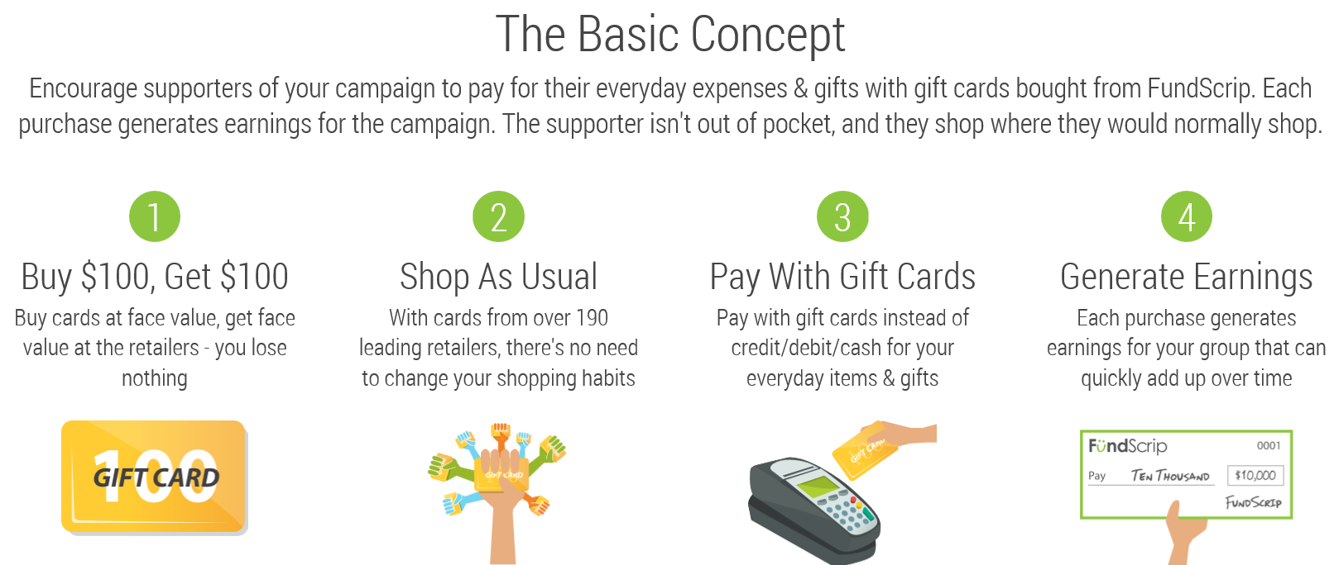
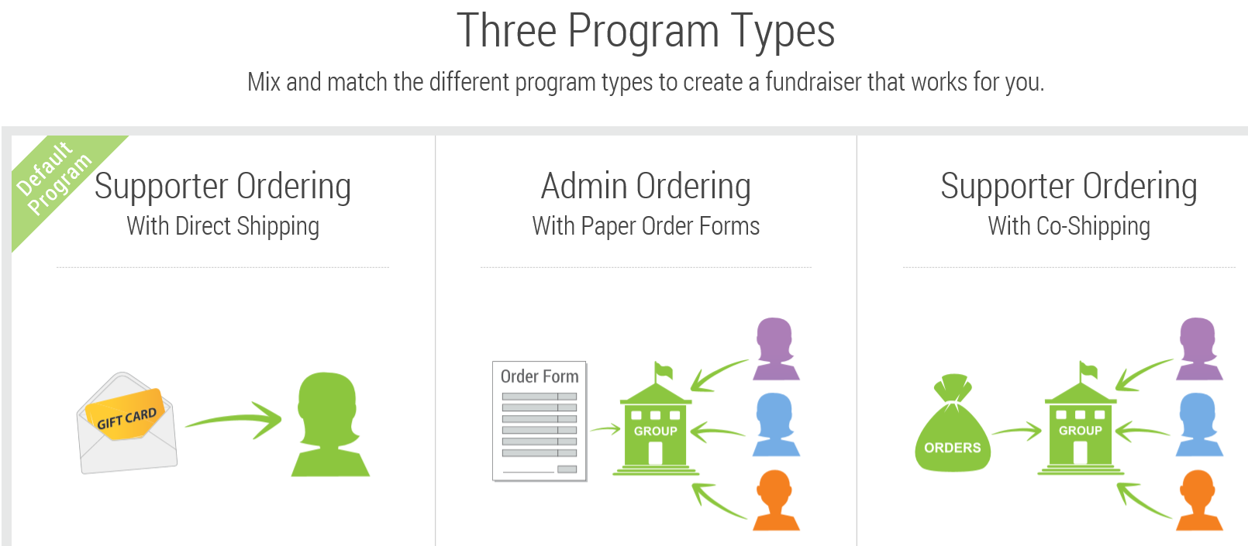
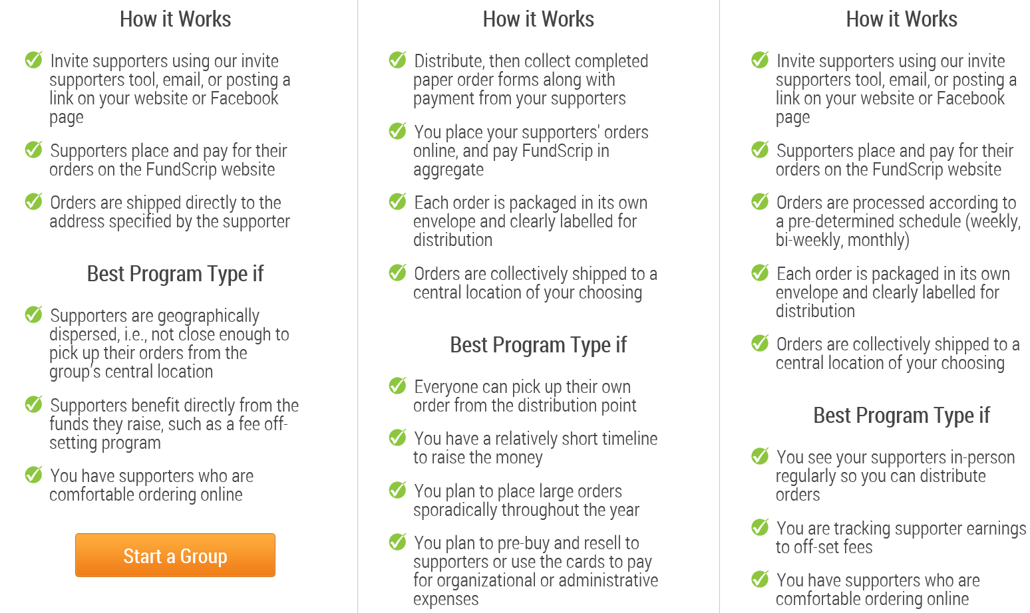

Epicure (Terra-Lee Larsen)
Emailed information sent under separate cover.

Selling Meats (Gunthers? / Two Rivers Meats, Vancouver)
https://www.tworiversmeats.ca/our-story/

Thrifty’s Smile Card Program
The CRSC is currently enrolled in this program. Their Community Relations Officer confirmed that this program is still available. So if anyone mentions the cashier only taking the Air Miles card make sure you give them your Smile Card too.

Pizza
I heard back from one of my CanSkate parents. Her daughter is one that is moving into STARSkate and participating on our float. They own Panago. Anyway, this is what they have offered us as an idea for a fundraiser.
Sell pizza coupons, they are one medium for $10 (usually $17) for each pizza coupon we sell it’s a $4 profit to the Club. Even selling them to club members as a smaller fundraising event.
Another thought was they could “cater” a potluck and charge per person or per family. Each large pizza would give a $10 profit to the Club. They could organize a veggie tray and a couple of salads to go with the pizza for the potluck dinners.
She says they are happy to help wherever they can.

Raffle
It is important that prizes are donated. Suggested that perhaps Cara would like to take this on as she has a wide variety of contacts. Recommend that you have lots of prizes that range in dollar value. Some suggestions of prizes are:
- WestJet Vacation
- Spa $200
- Basket from Gourmet Essentials
- Round of golf for two
- Fishing Charter
- Tyee Fishing, 2 tides
- Helicopter tour
- Movie tickets
- Gift certificate/Family Pass to Strathcona Gardens, swimming
Rene was going to contact Maria but I can’t remember why….oops. Tickets suggested price $5/each. Would be important to set up dates to sell at grocery stores.

Money Raffle
Apparently this is a big one for Minor Hockey.
Tag Day
Ideally it works well to have 2 smaller/younger skaters with an older skater. Work the cute factor.
Bagging Groceries
This does well and is more for the older skaters.

Bottle Drive
Holding it a week after New Year’s appears to be good timing. Minor hockey held two and made $3200. This organization definitely has more bodies to draw from.
Selling Chocolate Almonds or Purdy’s ($2/box max.) – will only really work if they are available to hand out at registration and since we are going to online registration details of how this would work is needed.
Pub Auction Night
Pub Auction Night hosted at SoCal (stands for Southern California) in Willow Point (http://www.socalrestaurant.net/). They made $4000. She thinks they sold tickets for $25 and the cost was $13’ish. They had donated items and fabulous baked goods. Lots of drinks were served. Apparently the cinnamon buns went for $100 lol I make fabulous UBC cinnamon buns!!! Free live entertainment every weekend. All family members welcome; they have a great kids menu.
